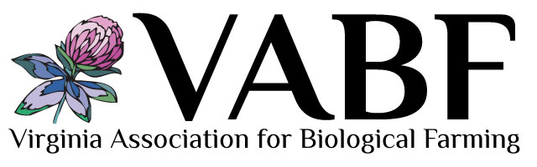
Old Church Creamery
Catherine Long, Co-owner
Manquin, Virginia
http://www.oldchurchcreamery.com/
info@oldchurchcreamery.com

Interview by Christy Gabbard of Local Concepts LLC on October 29, 2013.

Farming is a relatively new business for the Long family. Their love for dairy cows all began with a couple calves that were given as gifts to the four children and has since grown exponentially. While talking with Catherine it was obvious that her love for the animals and commitment to providing healthy, tasty food is what drives her to work the long hours required in a start-up dairy.

Tell me a little bit about yourself, your farm, and how you got started.
We’ve been at this current property in Manquin for five years. Old Church is where we got started, which is about ten miles southeast of here. There we were on ten acres with four cows. Our kids showed the cows at the Virginia state fair each year and they did real well. I milked one cow by hand and the others we always sold when they became mature. One day my husband said, “What if we started a business?” So we began with one cow, Brownie, and we got twenty-five other cows. They were pregnant teenagers and we started milking them.

At first we commuted from Old Church to this farm. We were commuting about one hundred miles a day. It was an absolute killer so we decided we needed to move closer. We came here and started shipping milk. I had taken a cheese makers course and had gotten my license in Wisconsin, and my husband said, “Why don’t we start making cheese?” So we got the micro-dairy, which is a small piece of equipment that allows you to make forty-five gallons of dairy products a day, and we started making one style of cheese.

From that one style of cheddar now we do ten varieties of cheese. That was about two years ago. Then over a short period of time we went from just cheese to making yogurt, Greek yogurt, kefir, and white milk. Now we also make chocolate milk and chocolate cheeses.

We started selling at farmer’s markets, restaurants, wineries, and four stores in Richmond. We now sell at six farmers markets in the summer and we have this store on the farm that we just opened in June.

About three months ago, we had an open house and we had over 100 people attend.

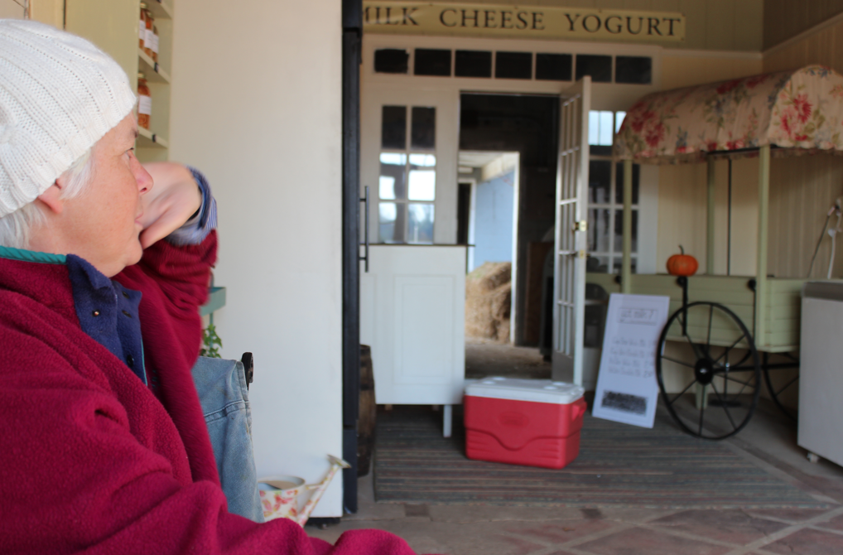

Wow, that is great!
Yes, the whole place was just packed. People stayed for four hours and we fed them. Then we did it again in August, September and October. The one we just had was crazy, there was no place to park a car, this entire place was filled with people. We had games and crafts. It was Customer Appreciation Day so we gave away pumpkins and the kids got to decorate the pumpkins, and we had a corn hole tournament. It was an all day affair. It was a lot of fun.

So you’ve incorporated some agritourism into your business model?
Just a little bit. We’ve also opened a store here at the farm. Basically how our store works is if someone comes we show them how to shop and then it is self-serve and the honor system after that.

Do people just stop by?
Yes, they are stopping by all the time.

Do you advertise?
We have over a thousand likes on our facebook, three hundred on our email list, and two hundred on our mailing list. We also sell through an internet farmers market that services fifteen different locations in the Richmond area.

Is that through Lulus Local Food?
Yes. We would like for that to grow. Lulus has been really fabulous for us because it is like a factory: you put in your availability, customers put their order in and then it is sold; whereas, when you go to a farmer’s market you bring a little bit of everything and you don’t know what is going to sell.

Now some markets we go to, like South of the James, we almost sell out every week no matter what we bring -- that is just a fabulous market. I think there are 1,200 people walking through there. Other markets that we are in are much smaller but they are consistent, so you know you are going to get so many buyers a week.

My husband launched us. He said, “Why don’t you do a trade show?” I had never done a trade show before, but we did it and people were able to stop by and sample our cheeses. At the trade show we were invited to sell at the Williamsburg Farmers Market and the Yorktown Farmers Market. We sold at both of those markets for a year but they were quite a drive -- fifty-one miles to Williamsburg and sixty-three to Yorktown. That was a lot.

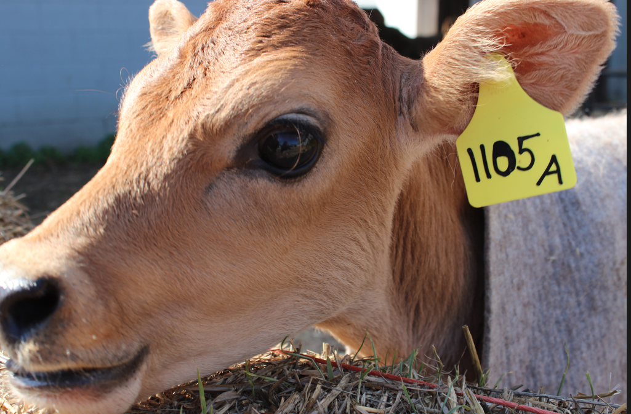

How has it been getting inspected to make cheese?
Oh, it was fine. We did not do anything without getting the inspectors involved in every single aspect because dairy is probably one of the most regulated food products out there. We first got inspected to be raw milk producers, which is what you are called when you ship milk to a processing plant. That is what we started as five years ago, which requires VDACS (Virginia Department of Agriculture and Consumers Services) approval. Then we went on to making cheese, which is also a VDACS approval. They were involved in the entire design and building of our plant. Then we wanted to add yogurt. Yogurt is a Grade A product so we had to involve the Virginia Department of Health. We had the Department of Health come with VDACS and they both inspected everything all over again.

It was very expensive to go from cheese into yogurt because you have to get all this testing equipment, you have to be certified, and you have to go through a testing course. We have to test all our milk for antibiotics even though we don’t use antibiotics. We are treated the same as Kraft, Pet, and Richfood. We have the same status as those guys.

We got the yogurt permit and then we added in bottled milk and that was a totally different permitting process. Now we have standards for our water, our milk, our cheese, our yogurt, and our bottled milk. Everything is tested. We have a lot of regulatory requirements that we have to meet.

Sounds like that must take a huge amount of time?
Yes, and I have to report everything. I have to make reports to the state for everything I test and then I have to keep files on every product and provide cheese samples for VDACS.

Did you love cheese before this?
We wanted to see what we could do that was different than your standard dairy. When we first started out we were making cheese three days a week and yogurt two days a week. Then we went up to yogurt four days a week and cheese one day a week. Now the chocolate milk we are making that two days a week and it sells out immediately; so I am not sure where we are heading with this.

Greek yogurt is our number one seller then the white milk and the chocolate milk. I think the chocolate milk is going to eclipse everything along with our chocolate cheese.

What type of farming practices do you use?
We don’t use pesticides, we don’t use hormones, we don’t use antibiotics, we don’t spray the fields with anything except for compost tea or fish emulsion, and we are non-GMO. We are thinking about totally dropping out the grain because it is really hard to find non-GMO grain that we can afford for our cows. If you have one cow it is not a big deal but if you have 62 then it is a different story.

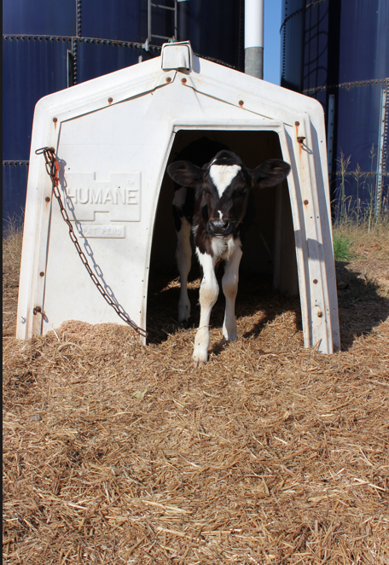
Are there any underlying values that made you move forward with farming?
My husband is a really big thinker and he could see that things were going on in mainstream agriculture that he was really not excited about. He read Omnivores Dilemma, which put Polyface on the map, and then Food Inc. came out. Then my husband became like a pilgrim and started going to see Joel Salatin and asking him questions about management, and that got him very into it. One day he said let’s just do this and now we’ve been doing it for five years. We’ve learned a lot.

The underlying feeling is maybe a sense of remorse about what is happening to the food system compared to what we had as kids and how it has changed overtime; and a sense of if you grow really healthy food people will want it. For example, we had a man come to me, he wanted a cow and it is had to be A2A2 because he could not digest the A1 protein common in milk. We are breeding all our cows to A2A2 bulls. Research shows the A2 protein is easier to digest.

What is the most rewarding part of this job?
The people, it is the people. We work way too many hours and you may get discouraged because you start at four in the morning and you are not done until ten or midnight. You do that day after day and then you also work long hours at the market. One time, though, I was at the market and this woman said, “You are the reason I come to this market.” I said, “Really?” And she said, “Yes, I am a breast cancer survivor and I have to have your kefir because it helps me and it helps my stomach.”

I get these kinds of comments all the time from people who like our kefir or our Greek yogurt. My husband sells at one of the markets and he said to me, “Do you realize, Catherine, this lady has taken our Greek yogurt down to MCV (Medical College of Virginia) because she has Crohn’s Disease. She took it there to have it researched to see if she could eat it and they told her she could eat it.” This woman told my husband that she feels great when she eats our yogurt. These are the kind of things that make you go “Okay, it is worth it,” because it has been a lot of sacrifice, there is no question about it.

What are some of your farming pleasures?
I take a lot of pleasure knowing that I can calm a wild animal by stroking her and telling her that I am here. These connections also make it worth it.

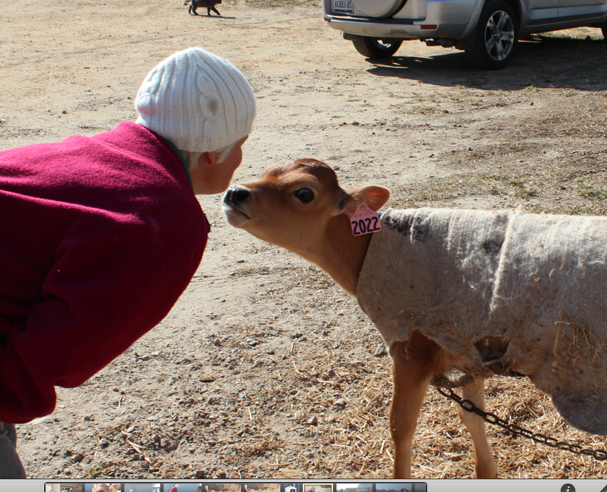

What is the most challenging part?
The long hours and the early hours, yesterday I got up at 2:30 and worked from 2:30 until noon, took a nap and then got up and made deliveries until 8 pm, and today I started at 4 am. I am often working in the rain or in the snow dealing with a cow that won’t walk with me, or a cow that has just given birth outside. It is cold and you’d like to be in bed.

From talking with other farmers it seems that it can be very difficult to make a living. What are your thoughts on making a livable wage?
We would be out of business if we shipped milk to the processing plant. We would have been out of business in the first three years, no question. When we ship milk we gross about $1.80 on a gallon of milk and we net about a quarter. You can’t survive on that.

With the micro-dairy we started making cheese and our cheese has orders of magnitude more value in it than the commodity milk. It definitely adds a lot of value. The yogurt just sells better because it is an immediate consumption product. Customers take a spoon and eat it right there at market.

When we added in cheese and yogurt there is no question that was very, very good. But still my husband cannot quit his job and I don’t take a salary. We have no debt, which is nice, but we could not live off of what we are making now. We will have to do something different in order for him to quit his day job.

Diversification is the answer for us. When we first diversified out of commodity milk into private label cheese and yogurt and now the bottled milk – that was great. Diversifying has been good.

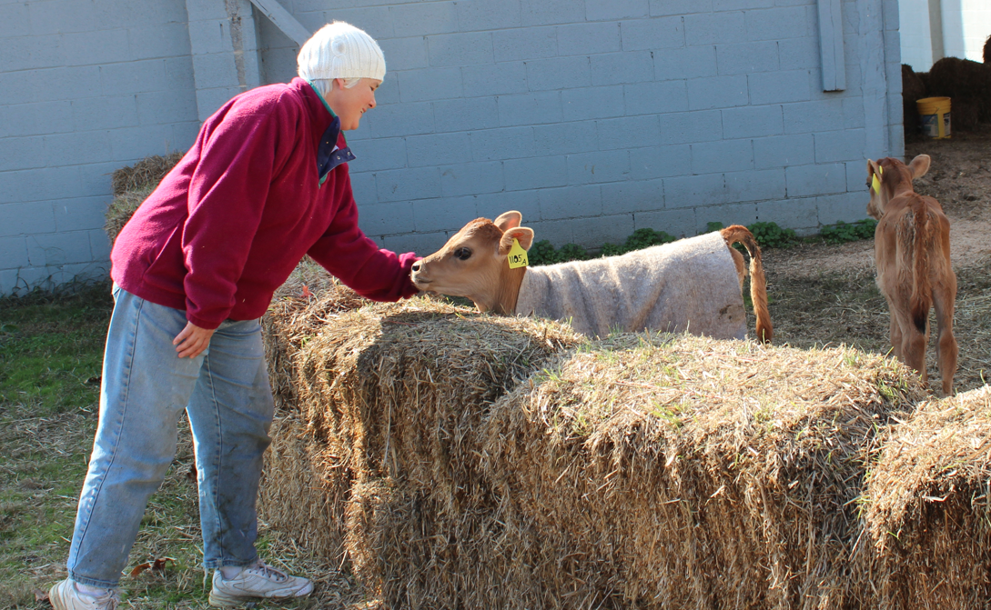

How have you received support from USDA?
Where USDA comes into our farm is through the grazing program. We do a cost share program with NRCS. They provide some compensation for putting up the fence and doing the intensive grazing.

Is that to fence out the creeks?
No, it is just to put cows on the land grazing so they are not in feedlots eating grain. It is not related to protecting water bodies. This program is meant to install grazing practices to raise cows that are grassfed. We were doing it anyway but USDA happened to have a program, so I signed up. It is a reimbursement program for installing these practices. We rip out the fence line and move it over everyday so that the cows are never standing on the same ground, as they were the day before. It is a lot of work everyday.

At a time when USDA is thinking of trimming the budget, do you think these programs are important?
Yes, because every little bit really helps. If you want healthy food and you want to encourage people to do good things with the land, then you need to have programs like this. It is a great incentive knowing that the government is standing behind you in doing a management practice that helps both the cow and the land, and the people who ultimately consume the products derived from the cow.

Without question it is a really great incentive. If you had someone who was going to give you $2000 to install a victory garden that would help a community, you would go, “Wow, that is an incentive,” and then you’d get on board and do it, and that is how I feel about us, we were doing it but we do a much better job because we know that they are providing incentives for us.

