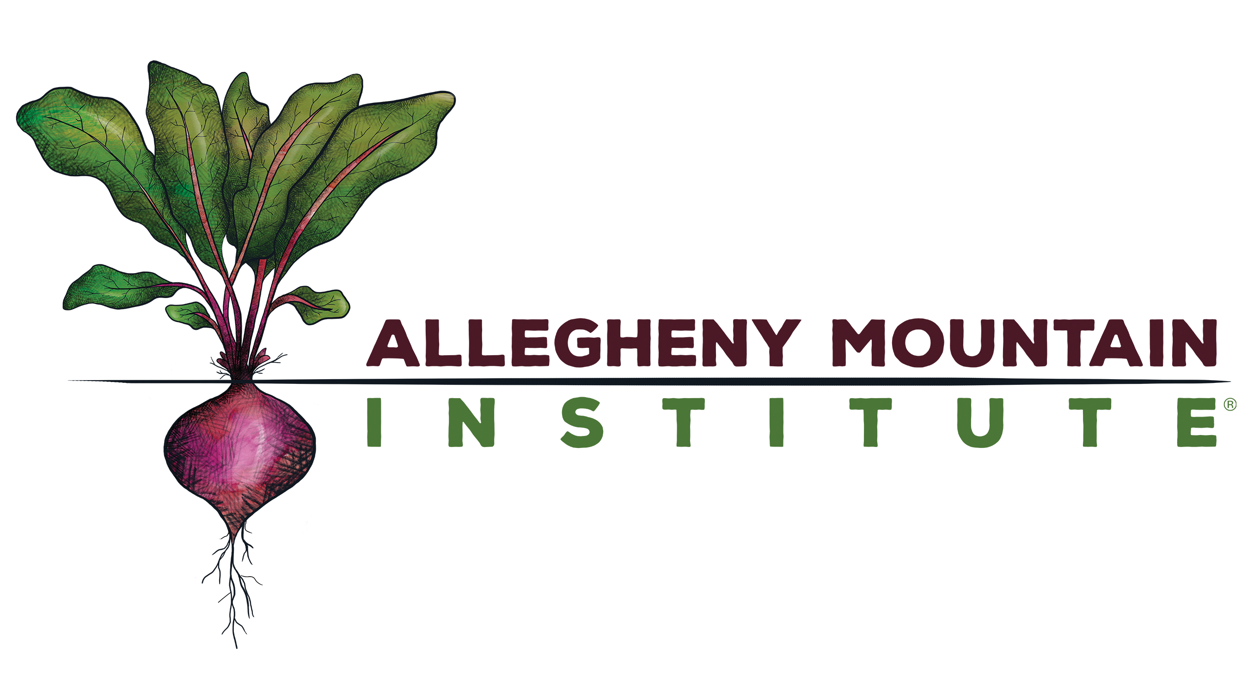

POSITION TITLE: Executive Director, Allegheny Mountain Institute

Allegheny Mountain Institute (AMI) is a 501(c)3 educational nonprofit organization founded in 2011 as Allegheny Mountain School as an intensive hands-on cooperative experiential learning and training program designed to teach members of our communities to grow and prepare their own food and to understand the nutritional benefits of eating seasonally.
MISSION: AMI cultivates healthy communities through food and education.

VISION: A thriving network of collaborative, vibrant communities who value the connection between food and health.

OUR PROGRAMS
The AMI Fellowship is an 18 month, two phase program. During Phase I in the first six months, AMI Farm Fellows live, work, and study at the Allegheny Mountain Farm Campus in Highland County, VA. They study sustainable food production, whole foods preparation and preservation, mindfulness, wellness and nutrition, land stewardship and community development, as they train to become ambassadors for a healthier food culture. In Phase II, from January – December of the following year, AMI Senior Fellows work in the service of AMI and/or a Partner Organization and focus on activities such as: building community gardens, developing school gardens and site based curriculum, advocating sustainable land use, teaching nutrition and cooking for a healthy lifestyle. AMI also operates the AMI Urban Farm at VSDB (Virginia School for the Deaf and the Blind) which provides students of all ages a place to learn, play and grow outdoors, trains educators in the community, and provides nutritious food for the community. That 3-acre site consists of a 1-acre vegetable farm, educational gardens, outdoor classroom and kitchen, orchard, and diverse native habitat plantings in a riparian buffer. Community work days, teacher trainings, workshops, Open Houses and Farm Stays are all part of the robust programming that AMI offers to our surrounding communities.

GENERAL DEFINITION AND PURPOSE OF WORK

Reporting to the Board of Directors, the Executive Director has overall management responsibility for Allegheny Mountain Institute’s staff, programs, finances, fundraising, execution of its mission and strategic plan.

DISTINGUISHING FEATURES OF THE POSITION

The AMI Executive Director position is a senior leadership and management position for a complex non-profit organization with multiple programs operating from multiple work sites. The ideal candidate must have at least 5 years of experience in non-profit management, finance, personnel management, and fundraising. Applicant resumes should display clear evidence of being a capable leader, organizer and motivator of groups of people. A strong commitment to regenerative agriculture, healthy food systems, and conservation is expected. The preferred candidate will have a passion for farming, gardening, and / or healthy food preparation. Since education of the broader community is a key component of the AMI programs, a competitive applicant should also have an interest and capabilities in community development, networking, and communications. The AMI Executive Director must be available to work occasional evenings and weekends, and should be willing to travel to rural work sites as needed to provide leadership and supervision for Farm Managers and other employees at those sites.

ESSENTIAL FUNCTIONS/ TASKS

Leadership & Management:

- Holds the organization’s vision, communicates the vision to stakeholders, and leads the team in the implementation of the vision
- Works with Board to develop and execute strategic plan, business plan, and annual operating plan.
- Supports all activities associated with the Board of Directors meetings, including: staffing support, meeting schedules and materials, locations, and assists with development of agenda.
- Provides information and support to the Board and its Committees in the creation of policies, programs, and strategic direction of the organization, and documents all activities pertaining to programs and events for Board meetings
- Negotiates contracts, real estate opportunities and leases, and supervises construction as necessary
- Oversees legal documents and insurance requirements
- Oversees the hiring, training, workflow, retention, performance appraisals, and professional development of staff
- Provides leadership to staff in the development and implementation of strategic plans for operations, educational programs, fundraising, and communications
- Oversees and participates in Fellow recruitment and continuing education
- Conducts regular staff meetings and oversees the administration of payroll and employee benefit program
- Oversees facilities management, including: office spaces, leases, and MOAs.
- Perform other related duties as assigned by the Board of Directors

Communication and Relationship Building

  - Acts as principal spokesperson, negotiator, liaison, ambassador, and advocate with other organizations, donors, outside vendors, partners, local community groups, and government agencies
  - Oversees publicity and marketing efforts, including the website, promotional materials, media opportunities

Finance and Fundraising
  - Works with the Board to develop organizational budget and annual fundraising plan
  - Manages all aspects of fundraising and philanthropic activities, and leads staff-Board development team
  - Maintains donor tracking systems and stewardship activities
  - Manages organizational budget and finances. Ensures proper accounting and reporting systems are in place and maintained in an accurate, timely manner.
  - Fundraises both in the private and public sector
  - Writes, coordinates, implements, and manages grant applications, follow-through, and reporting.
  - Coordinates and manages staff’s program grant applications and budgets

SUPERVISORY RESPONSIBILITIES

- The Executive Director directly recruits, trains, supervises, and evaluates the organization’s paid employees, and indirectly ensures the same for the Fellows.

QUALIFICATIONS: KNOWLEDGE, SKILLS, AND ABILITIES

- Bachelor’s degree and/or experience in a relevant field; Master’s degree preferred
- Minimum of five years executive management experience, preferably in an agriculture or food-related nonprofit organization
- Demonstrated leadership in the development and implementation of a strategic plan
- Demonstrated ability to secure funds from both the private and public sectors, steward individual donors, drive fundraising activities, and engage a Board of Directors in fundraising efforts
- Demonstrated experience in grant research, writing, and management
- Demonstrated experience in nonprofit financial management, reporting and budgetary oversight
- Exceptional multi-tasking, organizational and time management skills
- Excellent interpersonal and communication skills (both written and verbal), including public speaking as well as meeting facilitation
- Strong analysis, planning, and creative problem-solving skills
- Ability to work both independently and as part of a team
- Effective at fostering collaboration and building consensus
- Experience with organization outreach and marketing
- Computer proficiency, including QuickBooks and Microsoft Office/Apple iWorks
- Mentorship and/or education experience
- High level of personal and ethical standards
- Ability to understand, interpret and enforce policies in an accurate and equitable manner
- Ability to deal with customers, employees, and colleagues in a professional, timely, fair, and confidential manner
- Advanced knowledge of and experience in food production (farming/gardening)
- Knowledge of and commitment to sustainable food systems and conservation
- Interest in healthful cooking and nutrition
- A valid driver’s license with a good driving record

PHYSICAL REQUIREMENTS OF THE POSITION:

This is both sedentary work in an office environment and physical work which requires the exertion of negligible amount of force to move objects, up to 10 pounds of force frequently and some light work requiring the exertion of up to 50 pounds of force occasionally. Work requires stooping, reaching, grasping and repetitive motions; typing/word processing requires the ability to perform repetitive tasks involving fine motor skills. Vocal communication is required for expressing or exchanging information and instructions by means of the spoken word; hearing is required to perceive information at normal spoken word levels, and to receive detailed information through oral communications and/or to make fine distinctions in sound; visual acuity is required for driving, preparing and analyzing written or computer data, operation of machines, determining the accuracy and thoroughness of work, and observing general surroundings and activities; the work is not subject to adverse environmental conditions.

COMPENSATION

This is a full time, executive level, exempt position. The compensation package includes a salary of $48 – 53k (commensurate with experience) with basic benefits.

NON-DISCRIMINATION POLICY:

Allegheny Mountain Institute does not discriminate on the basis of race, color, gender, age, sexual orientation, national and ethnic origin, disability, political affiliation, or marital status. AMI is an equal opportunity employer.

